DSA 0601 - Data handling and visualization
Set 9 -Online Learning Activity

Name : B.Jahnavi
Reg.no:192325043

1.Histogram and Boxplot
Program:

library(ggplot2)
learning <- data.frame(
Student_ID = c("L01", "L02", "L03", "L04", "L05", "L06"),
Gender = c("Male", "Female", "Male", "Female", "Male", "Female"),
Age = c(20, 22, 19, 21, 23, 20),
Course = c("R", "R", "SQL", "R", "R", "SQL"),
Study_Time = c(3.5, 4.2, 2.0, 5.0, 2.5, 4.0),
Videos_Watched = c(12, 15, 8, 18, 9, 14),
Quiz_Score = c(78, 85, 65, 92, 70, 88),
Login_Date = as.Date(c(
"2025-01-05",
"2025-01-05",
"2025-02-08",
"2025-02-08",
"2025-03-12",
"2025-03-12"
))
)

ggplot(
learning,
aes(x = Quiz_Score)
) +
geom_histogram(
bins = 5,
fill = "steelblue",
color = "black"
) +
labs(
title = "Distribution of Quiz Scores",
x = "Quiz Score",
y = "Number of Students"
) +
theme_minimal()
ggplot(
learning,
aes(
x = Course,
y = Quiz_Score,
fill = Course
)
) +
geom_boxplot() +
labs(
title = "Quiz Score Distribution by Course",
x = "Course",
y = "Quiz Score"
) +
theme_minimal()

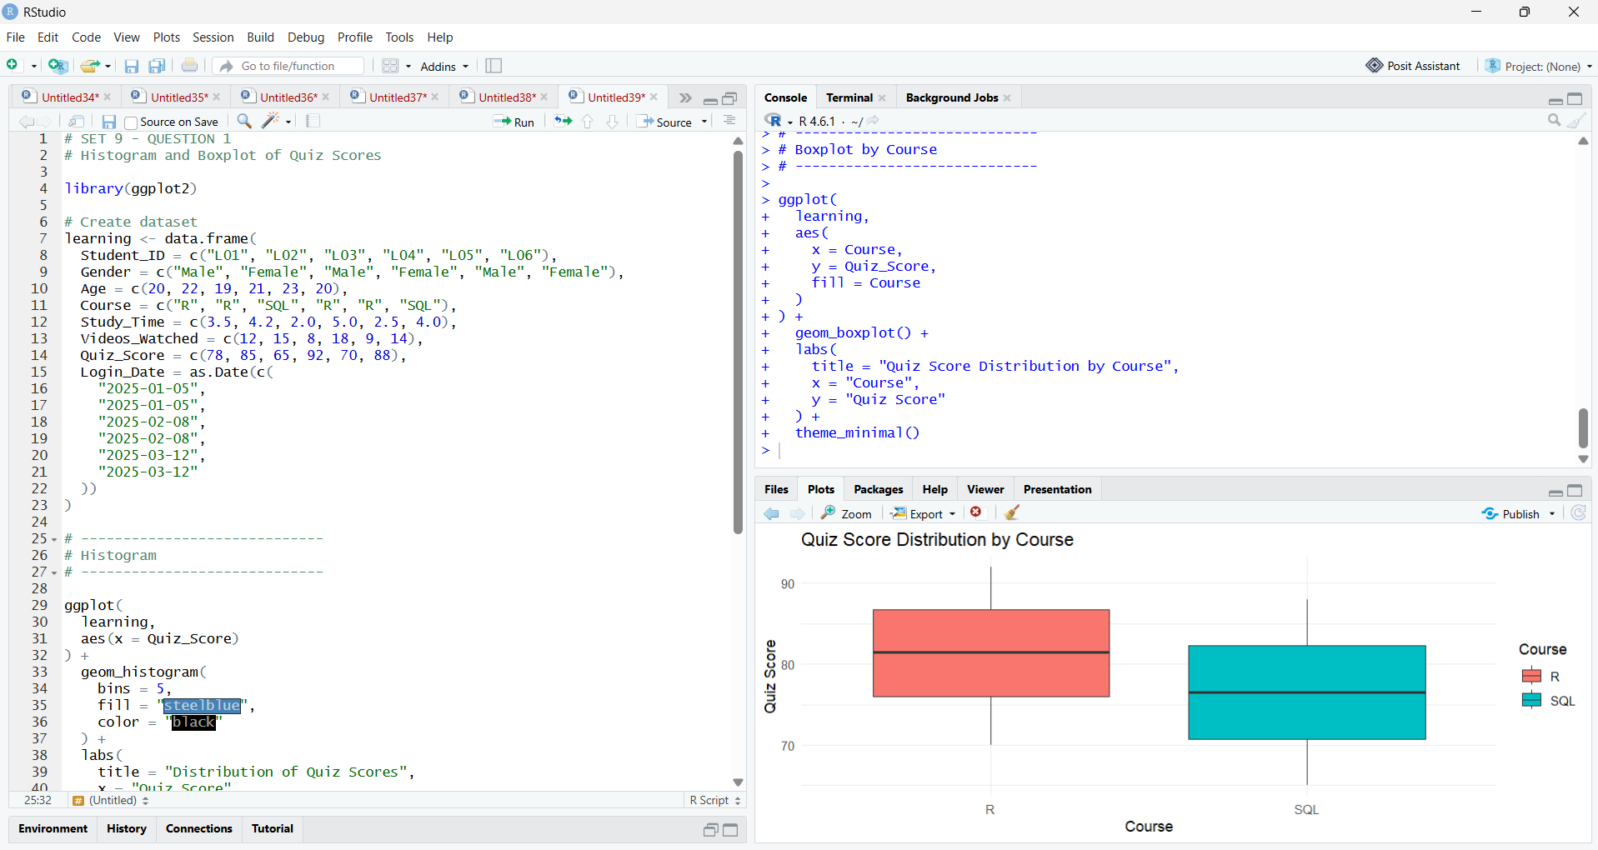

2.Scatter Plot with Bubble Size
Program:

library(ggplot2)

# Create dataset
learning <- data.frame(
Student_ID = c("L01", "L02", "L03", "L04", "L05", "L06"),
Gender = c("Male", "Female", "Male", "Female", "Male", "Female"),
Course = c("R", "R", "SQL", "R", "R", "SQL"),
Study_Time = c(3.5, 4.2, 2.0, 5.0, 2.5, 4.0),
Videos_Watched = c(12, 15, 8, 18, 9, 14),
Quiz_Score = c(78, 85, 65, 92, 70, 88)
)

# Create scatter plot
ggplot(
learning,
aes(
x = Study_Time,
y = Quiz_Score,
size = Videos_Watched,
color = Course
)
) +
geom_point(alpha = 0.6) +
labs(
title = "Study Time vs Quiz Score",
x = "Study Time (hours)",
y = "Quiz Score",
size = "Videos Watched",
color = "Course"
) +
theme_minimal()

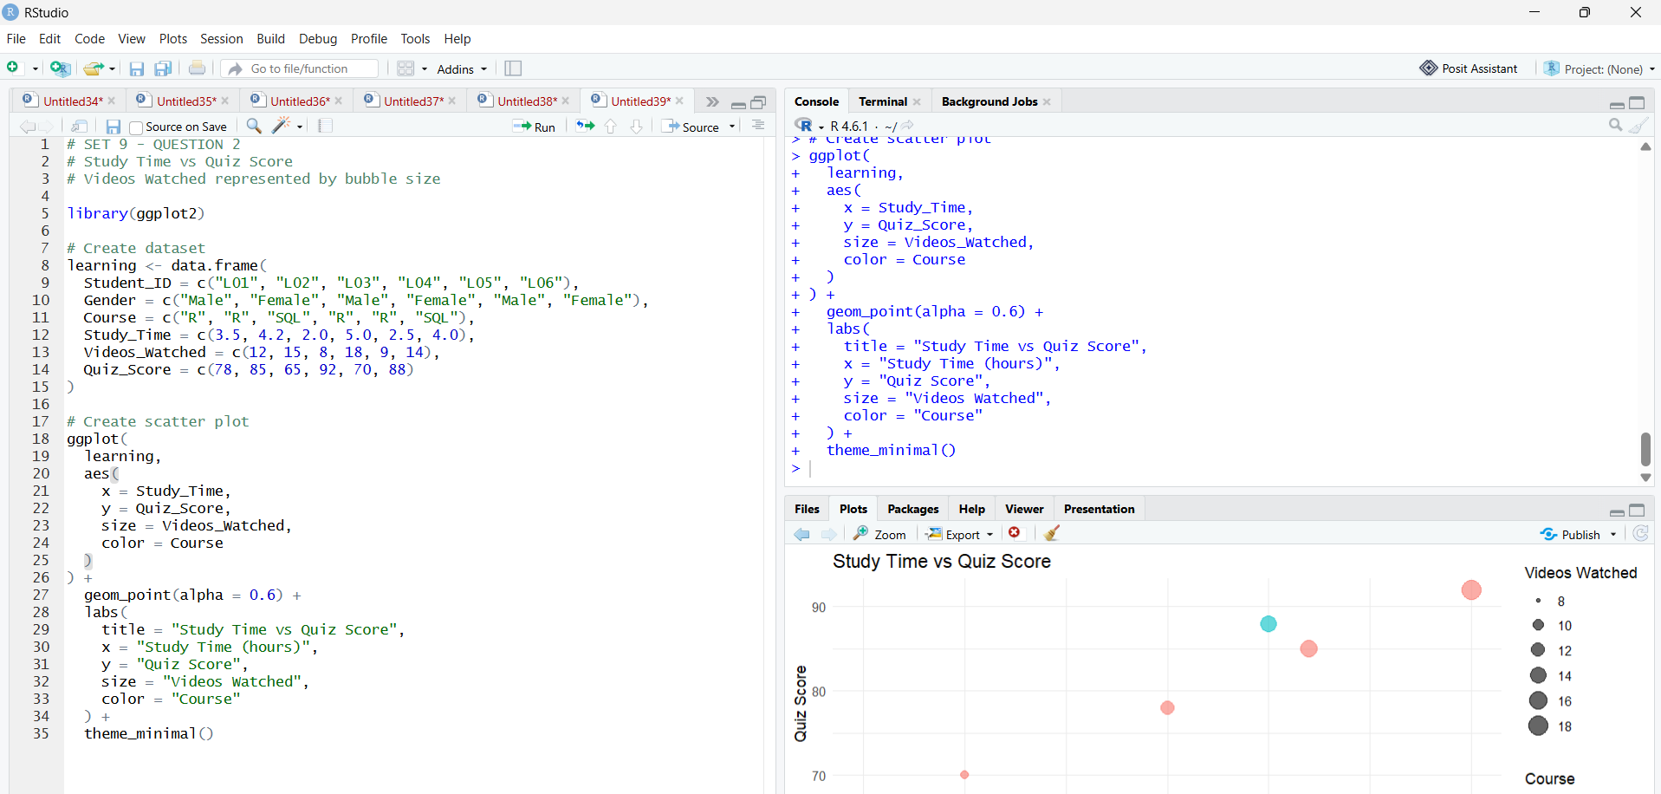

3.Monthly Average Quiz Score and Moving Average
Program:

library(ggplot2)
library(dplyr)
library(zoo)

# Create dataset
learning <- data.frame(
Student_ID = c("L01", "L02", "L03", "L04", "L05", "L06"),
Quiz_Score = c(78, 85, 65, 92, 70, 88),
Login_Date = as.Date(c(
"2025-01-05",
"2025-01-05",
"2025-02-08",
"2025-02-08",
"2025-03-12",
"2025-03-12"
))
)

# Convert Login_Date into Date format
learning$Login_Date <- as.Date(learning$Login_Date)

# Extract month
learning$Month <- format(
learning$Login_Date,
"%Y-%m"
)

# Calculate average quiz score per month
monthly_scores <- learning %>%
group_by(Month) %>%
summarise(
Average_Quiz_Score = mean(Quiz_Score)
)

print(monthly_scores)

# Calculate 2-month moving average
monthly_scores$Moving_Average <- zoo::rollmean(
monthly_scores$Average_Quiz_Score,
k = 2,
fill = NA,
align = "right"
)

# Convert Month to Date for plotting
monthly_scores$Month_Date <- as.Date(
paste0(monthly_scores$Month, "-01")
)

# Plot monthly average and moving average
ggplot(
monthly_scores,
aes(x = Month_Date)
) +
geom_line(
aes(
y = Average_Quiz_Score,
color = "Average Quiz Score"
),
linewidth = 1
) +
geom_point(
aes(
y = Average_Quiz_Score,
color = "Average Quiz Score"
),
size = 3
) +
geom_line(
aes(
y = Moving_Average,
color = "Moving Average"
),
linewidth = 1,
linetype = "dashed"
) +
labs(
title = "Monthly Average Quiz Score",
x = "Month",
y = "Quiz Score",
color = "Measure"
) +
theme_minimal()

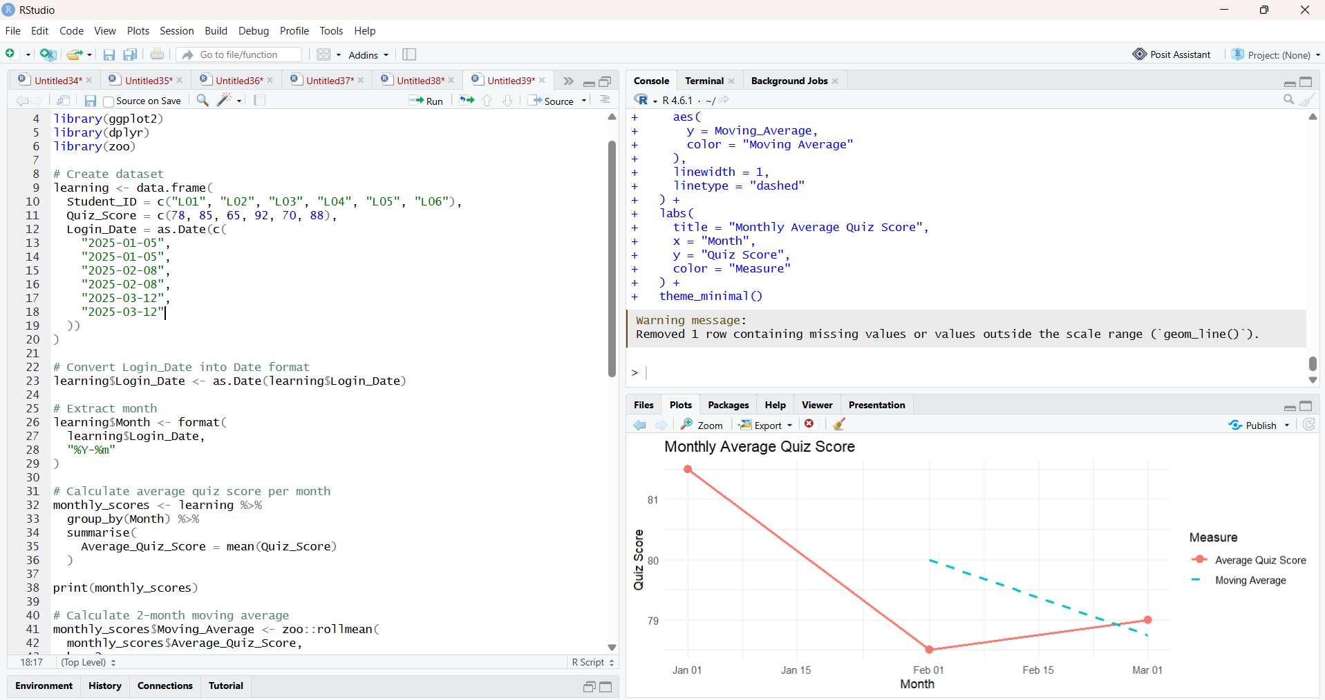

4.Tableau Dashboard
Program:

learning <- data.frame(
Student_ID = c("L01", "L02", "L03", "L04", "L05", "L06"),
Gender = c(
"Male", "Female", "Male",
"Female", "Male", "Female"
),
Age = c(20, 22, 19, 21, 23, 20),
Course = c(
"R", "R", "SQL",
"R", "R", "SQL"
),
Study_Time = c(
3.5, 4.2, 2.0,
5.0, 2.5, 4.0
),
Videos_Watched = c(
12, 15, 8,
18, 9, 14
),
Quiz_Score = c(
78, 85, 65,
92, 70, 88
),
Login_Date = as.Date(c(
"2025-01-05",
"2025-01-05",
"2025-02-08",
"2025-02-08",
"2025-03-12",
"2025-03-12"
))
)
write.csv(
learning,
"Online_Learning_Activity.csv",
row.names = FALSE
)
print("Online_Learning_Activity.csv created successfully!")

